**Technical Handbook Document**

**Azure Infrastructure Setup for ESD Application**

Prepared exclusively for:

AIS OraExit Client

By:

“Tech Mahindra”

March 1st, 2023

[Version 1.0]

Document History

Version

|  |  |  |  |  |
| --- | --- | --- | --- | --- |
| Name | Role | Created date  mm/dd/yyyy | Review Date | Version |
| Mohit M Singh | Technical Lead - DevOps, Tech Mahindra | 9/10/2022 |  | 1.0 |
|  |  |  |  |  |
|  |  |  |  |  |

Contacts: AIS OraExit Client

|  |  |  |
| --- | --- | --- |
| Name | Position | Contact Tel / E-Mail |
|  |  |  |
|  |  |  |

Contacts: TechMahindra

|  |  |  |
| --- | --- | --- |
| Name | Position | Contact Tel / E-Mail |
| Mohit M Singh | Technical Lead – DevOps | MS00866501@techmahindra.com |
| Deepak Chinta | Technical Lead – Azure | CD00872210@techmahindra.com |
|  |  |  |

# Table of Contents

Table of Contents 3

1 NAS to On-Prem File Sync Task Scheduler Setup 4

1.1 Step 1 - Encrypt Azure Principal Account [One Time Activity] 4

1.2 Step 2 - Setup NAS Secrets in Key Vault to pass variables in the script [One Time Activity] 6

1.3 Step 3 - Make changes to Main PowerShell script (NASSync2OnPrem.ps1) 7

1.4 Step 4 – Configure Task Scheduler 7

2 Batch Job Setup 9

2.1 Assumptions & Consideration 9

2.2 Location of Batch job in Task Scheduler 9

2.3 Create/Enable Task Scheduler using CICD 11

1.1 Clone CICD Repository & Add Exported Task Scheduler xml file 11

2.1 Navigate to CICD Pipeline Repository 11

3.1 Select appropriate Selection 11

3 Github Self-Hosted Runner 13

3.1 Connection Between VM to VM using WinRM 13

4 Additional Info & Issue Workaround 15

4.1 Use XCopy 15

4.2 ChromeDriver not executable 15

4.3 Restart Runner Services 15

# NAS to On-Prem File Sync Task Scheduler Setup

## Step 1 - Encrypt Azure Principal Account [One Time Activity]

Copy the below attached zip to specific VM where we have storage sync service installed onto **D: Drive** and extract the file there:



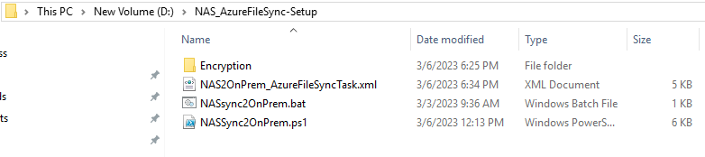

Go to the same path as above where you have copied the zip file to and that specific Path, navigate to D:\Azure_NAS_FileSync\Encryption and double click on “Startup.bat”

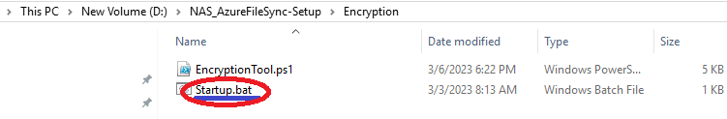

In this step, be ready with Client Id, Client Secret Id, Subscription Id, Tenant Id, Key Vault Name and pass the value as per the following: the same can be seen from the below screenshot as well

Enter Environment Name [Eg. dev]: <Enter Environment this setup needs to be done>

Enter your Client Secret [dev]: <copy paste client secret>

Enter your Client Id [dev]: <copy paste client id>

Enter your Tenant Id [dev]: <copy paste tenant id>

Enter your Subscription Id [dev]: <copy paste subscription Id>

Enter your Key Vault Name [dev]: <copy paste vault name>

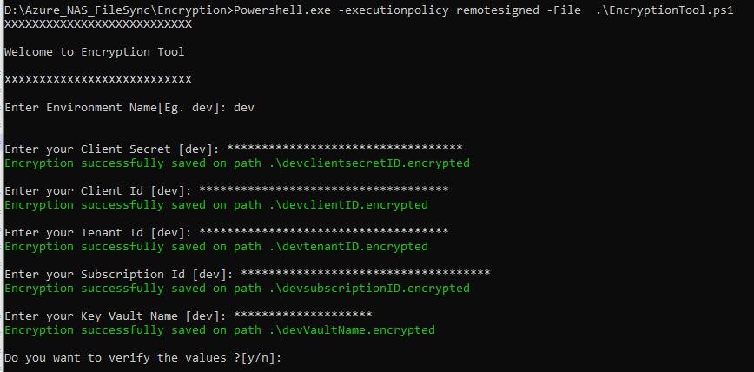

If you want to double verify the values what you have entered, type “y” and it will provide you the details as below:

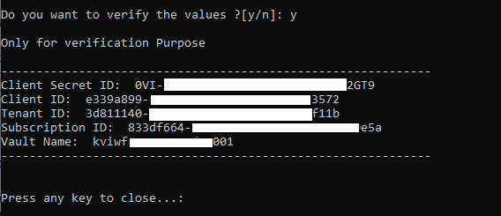

Post this, 5 encryption files will be generated on the path:

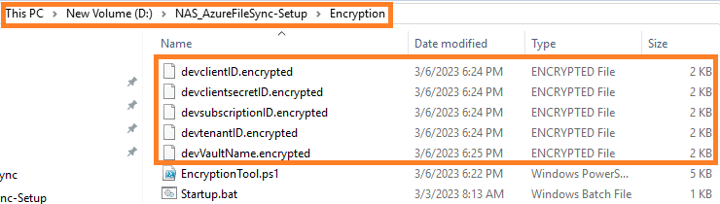

## Step 2 - Setup all the confidential values related to NAS & Azure File share storage as Secrets in Key Vault to pass them as variables in the script [One Time Activity]

**Navigate to Azure Portal 🡪 Key Vault 🡪 Select Key Vault 🡪 Secrets**

*Please note: How to add secret in Azure key vault? Refer:* [*https://learn.microsoft.com/en-us/azure/key-vault/secrets/quick-create-portal#add-a-secret-to-key-vault*](https://learn.microsoft.com/en-us/azure/key-vault/secrets/quick-create-portal#add-a-secret-to-key-vault)

**Add 10 Secrets as below:**

**Please Note:** Use comma “,” separation for multiple values except Keys like *NAS-rgName, NAS-CloudEndpointName, NAS-StorageSyncServiceName and NAS-SyncGroupName*

|  |  |  |
| --- | --- | --- |
| Key (Secret) | Value | Explanation |
| NAS-PATH | \\10.137.XX.X\sht_sdwf,\\10.138.XX.X\sht_sbnwf | \\10.137.XX.X\sht_sdwf belongs to [NAS1]  \\10.138.XX.X\sht_sbnwf belongs to [NAS2] |
| NAS-SOURCE-DEV | \DEV\DATA1\,\STG\DATA2\ | NAS source path (**Parent** **path**) from where the data needs to be fetched  \DEV\DATA1\ belongs to [NAS1]  \STG\DATA2\ belongs to [NAS2] |
| NAS-FolderToSync** | EDS_Attachment,PCS_Cost_Sheet,Quotation_Solution,folder4 | NAS source folder (**Child folder**) from where the data needs to be fetched  **\*\***If [NAS1] has folder Name EDS_Attachment and [NAS2] has PCS_Cost_Sheet, Quotation_Solution and folder4 you still need to add with comma separated. If you want all folders (*) please add names of all folder with comma separated |
| NAS-DESTINATION | D:\sht_sdwf,D:\sht_sbnwf | OnPrem Destination path where the files will be copied from NAS path  D:\sht_sdwf belongs to [NAS1]  D:\sht_sbnwf belongs to [NAS2] |
| NAS-MachineUser | corp-aisXXXdev\nas_nwf1,corp-aisXXXdev\nas_nwf2 | NAS Machine Login user  corp-aisXXXdev\nas_nwf1 belongs to [NAS1]  corp-aisXXXdev\nas_nwf2 belongs to [NAS2] |
| NAS-MachinePwd | Password@1,Password@2 | NAS Machine Login pwd  Password@1 belongs to [NAS1]  Password@2 belongs to [NAS2] |
| NAS-rgName | Example:  rg-EnterpriseAppOperation-az-asse-dev-001 | Assumption: the value will be same for all NAS to a particular environment.  Get the value from Azure side, Resource Group of storage sync service used for this environment |
| NAS-CloudEndpointName | Example:  112b9026-XXXX-XXXX-XXXX-0e70e17aaf64 | Assumption: the value will be same for all NAS to a particular environment.  Get the value from Azure side, Cloud Endpoint created for Sync group of storage sync service used for this environment |
| NAS-StorageSyncServiceName | Example:  sss-enterpriseapp-az-asse-dev-001 | Assumption: the value will be same for all NAS to a particular environment.  Get the value from Azure side, Storage Sync Service used for this environment |
| NAS-SyncGroupName | Example:  iwf-pcs-syncgroup1-dev, iwf-pcs-syncgroup2-dev | Assumption: the value will be same for all NAS to a particular environment.  Get the value from Azure side, the Sync Group Name used for this from the Storage Sync Service. |

**How to modify existing secrets?**

You just need to create new versions of the existing secrets and use the updated value tab to update the new value in secret.

## Step 3 - Make changes to Main PowerShell script (NASSync2OnPrem.ps1)

Navigate to D:\Azure_NAS_FileSync\NASSync2OnPrem.ps1

Verify or update only below two values:

* $ennv :- this should be the environment you entered in step 12.1.1 🡪 iii
* $EncryptionPath :- where all your encrypted files are present Step 12.1.1 🡪 v.

Save the file.

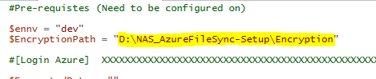

## Step 4 – Configure Task Scheduler

Open “Task Scheduler” 🡪 Click on Import Task

Navigate to path: D:\Azure_NAS_FileSync and select NAS2OnPrem_AzureFileSyncTask.xml

and import the file

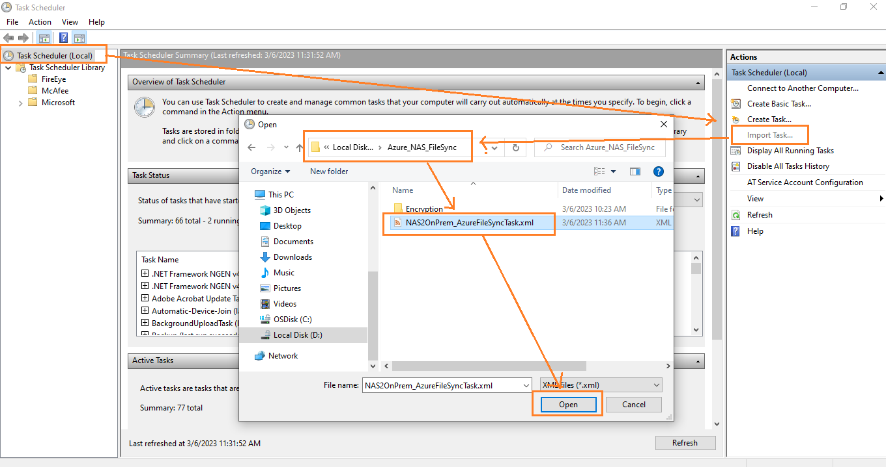

You will see the task scheduler under the path \EntApps\NAS2OnPrem_AzureFileSyncTask

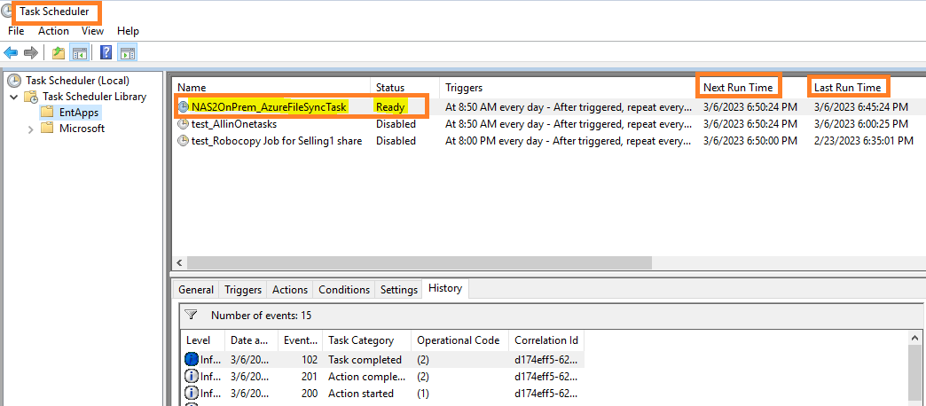

Check for Action and the path, it should map to D:\NAS_AzureFileSync-Setup \NASsync2OnPrem.bat

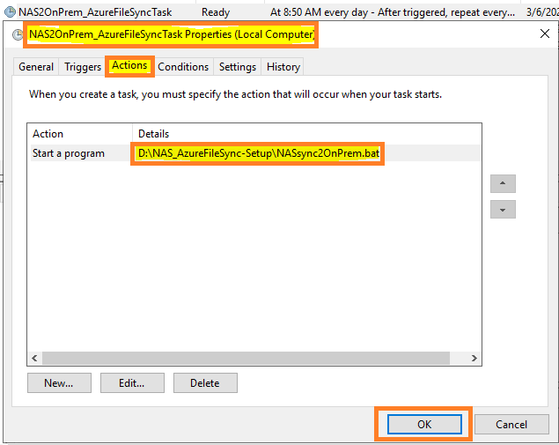

# Batch Job Setup

## Assumptions & Consideration

The following details are assumptions before proceeding with Batch Job Setup

Azure VM machine are already provisioned for Batch Job

**For DEV, SIT, UAT**

|  |  |
| --- | --- |
| [vm-batchappIWFCOA-az-asse-dev-001](https://portal.azure.com/?quickstart=true#@mimotech.onmicrosoft.com/resource/subscriptions/3d811140-0149-4811-912c-a0433e06f11b/resourceGroups/rg-EnterpriseAppOperation-az-asse-dev-001/providers/Microsoft.Compute/virtualMachines/vm-batchappIWFCOA-az-asse-dev-001) | Iworkflow,COA |
| [vm-batchappCORPBKO-az-asse-dev-001](https://portal.azure.com/?quickstart=true#@mimotech.onmicrosoft.com/resource/subscriptions/3d811140-0149-4811-912c-a0433e06f11b/resourceGroups/rg-EnterpriseAppOperation-az-asse-dev-001/providers/Microsoft.Compute/virtualMachines/vm-batchappCORPBKO-az-asse-dev-001) | CORP BKO |
| [vm-batchappCORPSMIS-az-asse-dev-001](https://portal.azure.com/?quickstart=true#@mimotech.onmicrosoft.com/resource/subscriptions/3d811140-0149-4811-912c-a0433e06f11b/resourceGroups/rg-EnterpriseAppOperation-az-asse-dev-001/providers/Microsoft.Compute/virtualMachines/vm-batchappCORPSMIS-az-asse-dev-001) | SMIS |
| [vm-batchappCORPPRF-az-asse-dev-001](https://portal.azure.com/?quickstart=true#@mimotech.onmicrosoft.com/resource/subscriptions/3d811140-0149-4811-912c-a0433e06f11b/resourceGroups/rg-EnterpriseAppOperation-az-asse-dev-001/providers/Microsoft.Compute/virtualMachines/vm-batchappCORPPRF-az-asse-dev-001) | PRF |

**For PRD**

|  |  |
| --- | --- |
| [vm-batchappIWFCOA-az-asse-prd-001](https://portal.azure.com/?quickstart=true#@mimotech.onmicrosoft.com/resource/subscriptions/3d811140-0149-4811-912c-a0433e06f11b/resourceGroups/rg-EnterpriseAppOperation-az-asse-dev-001/providers/Microsoft.Compute/virtualMachines/vm-batchappIWFCOA-az-asse-dev-001) | Iworkflow,COA |
| [vm-batchappCORPBKO-az-asse-prd-001](https://portal.azure.com/?quickstart=true#@mimotech.onmicrosoft.com/resource/subscriptions/3d811140-0149-4811-912c-a0433e06f11b/resourceGroups/rg-EnterpriseAppOperation-az-asse-dev-001/providers/Microsoft.Compute/virtualMachines/vm-batchappCORPBKO-az-asse-dev-001) | CORP BKO |
| [vm-batchappCORPSMIS-az-asse-prd-001](https://portal.azure.com/?quickstart=true#@mimotech.onmicrosoft.com/resource/subscriptions/3d811140-0149-4811-912c-a0433e06f11b/resourceGroups/rg-EnterpriseAppOperation-az-asse-dev-001/providers/Microsoft.Compute/virtualMachines/vm-batchappCORPSMIS-az-asse-dev-001) | SMIS |
| [vm-batchappCORPPRF-az-asse-prd-001](https://portal.azure.com/?quickstart=true#@mimotech.onmicrosoft.com/resource/subscriptions/3d811140-0149-4811-912c-a0433e06f11b/resourceGroups/rg-EnterpriseAppOperation-az-asse-dev-001/providers/Microsoft.Compute/virtualMachines/vm-batchappCORPPRF-az-asse-dev-001) | PRF |

## Location of Batch job in Task Scheduler

**Login to the VM**

Click on start -🡪 type “task scheduler”

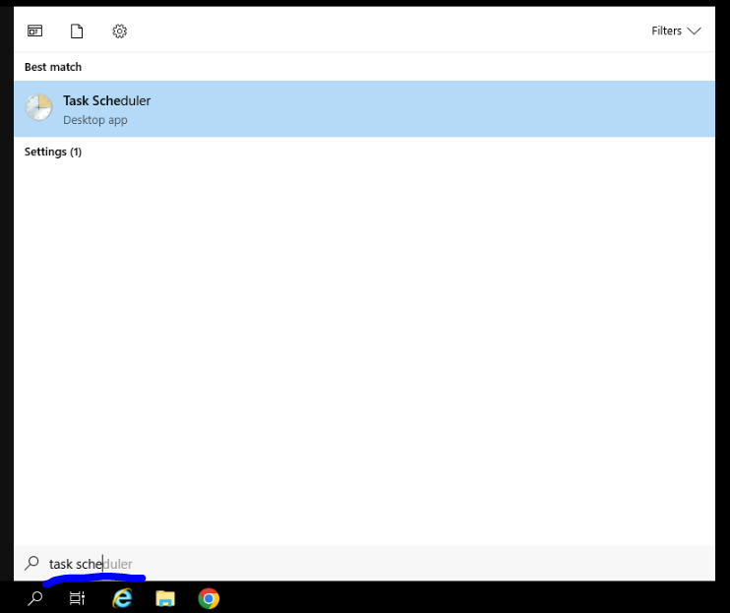

**Click on Task Scheduler Library to collapse and show sub path**

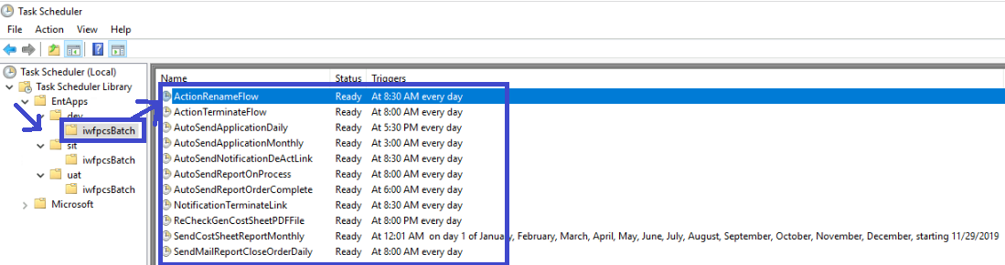

**Physical Path mapped to batch job is**

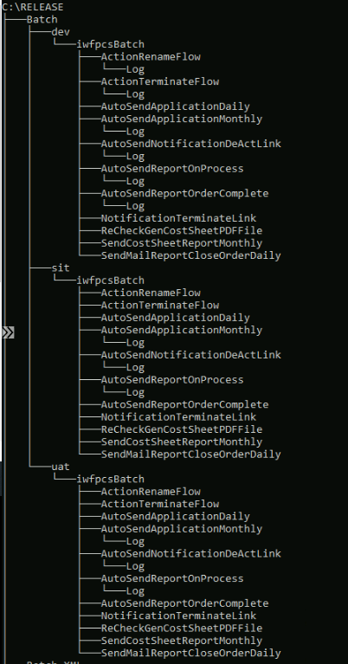

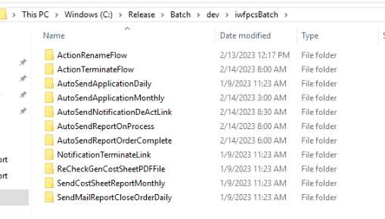

## Create/Enable Task Scheduler using CICD

### Clone CICD Repository & Add Exported Task Scheduler xml file

Place all the xml files to path /taskscheduler and also add the task scheduler name to file /taskscheduler/**SchedulerName.txt**

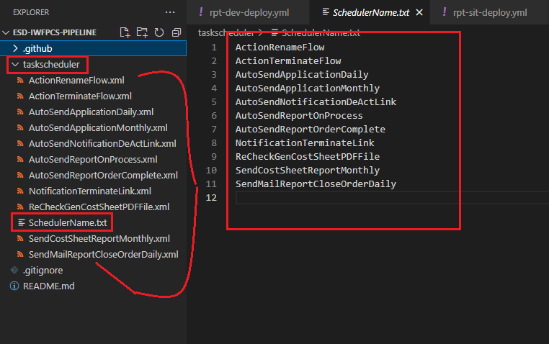

### Navigate to CICD Pipeline Repository

Select CICD Repository of respective application and click on “**Register Task Scheduler**”

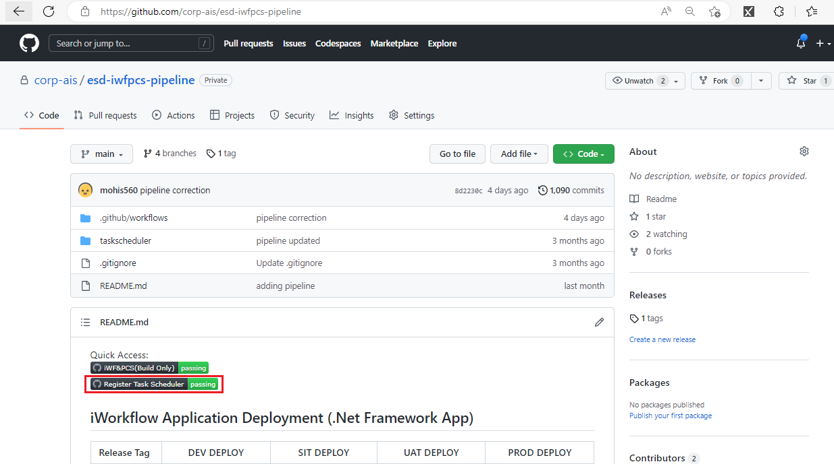

### Select appropriate Selection

* Environment: dev/sit/uat/prd <select environment>
* Keep Status: Disable/Enable <if you want to disable or enable task scheduler>
* Is First Time Provisioning? $false/$true <if you are doing it for first time, select $true else $false>
* Run the workflow

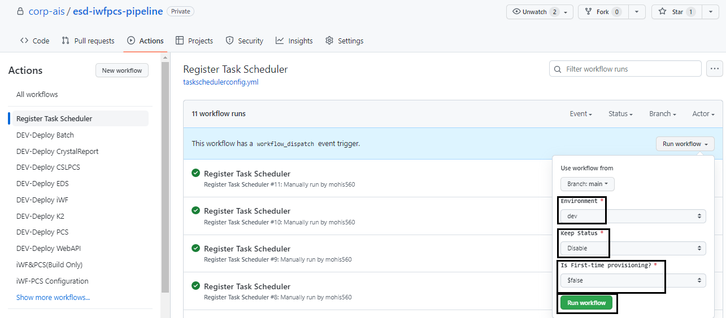

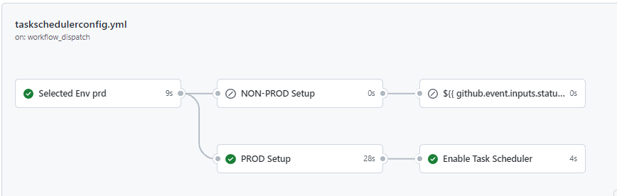

This will enable/disable the Task Scheduler as per your request.

# Github Self-Hosted Runner

The following details are defined as part of CI CD Implementation from TechMahindra and AIS OraExit Client:

* Recommendation & Consideration

1. Application team are **not required** to create multiple web.config files for each environment. This can be managed from Azure portal and CICD.

## Connection Between VM to VM using WinRM

For Windows, File transfer from “vmshrunXXXdXX” (GIT Runner) to “vmshimgXXXdXX” (Crystal ReportVM) can be achieved via Remote Powershell. No software installation is required.

The following details are defined required to setup communication between both the VMS:

* Setup Needed

1. Enable port **5985** WimRM on both the servers internally and from the portal. This has been done by me on both the server to create secured communication between the VM.

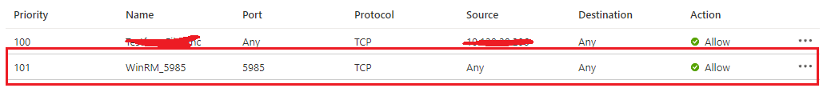

1. Add the IP address to TrustedHosts “WSMan:\localhost\Client\TrustedHosts” on respective machine. (On Server/Client Machine)
2. Run the winrm quickconfig command in Command Prompt to analyzes and share configuration of WinRM service (On Server/Client Machine)
3. Run “Enable-PSRemoting –Force” to enable the PSRemoting (On Server/Client Machine)

**Transfer Files:**

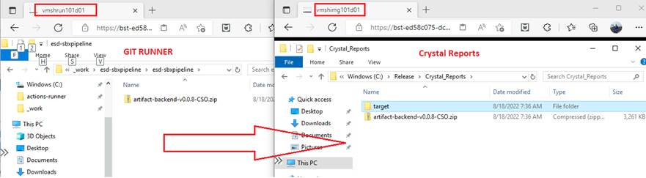

**Access Remote VM Services:**

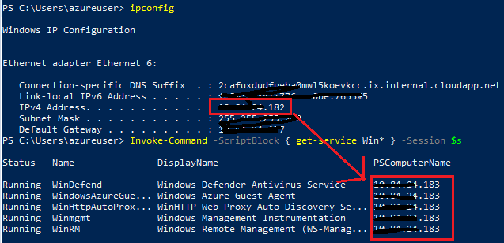

References:

[powershell - Can we connect to Azure VM remotely which is different Virtual Network - Stack Overflow](https://stackoverflow.com/questions/52368814/can-we-connect-to-azure-vm-remotely-which-is-different-virtual-network)

[Tutorial Powershell - Copy files to remote computers [ Step by step ] (techexpert.tips)](https://techexpert.tips/powershell/powershell-copy-files-remote-computers/)

# Additional Info & Issue Workaround

## Use XCopy

  #   - name: Copy to WORKING_DIR_IWF2 Folder

  #     run: |

  #          xcopy /y /s /d /e /i ".\${{ matrix.batch1 }}\bin\Release\*" ".\${{ env.DOWNLOAD_PATH }}\${{ matrix.batch1 }}"

  #     working-directory: ${{ env.WORKING_DIR_IWF1 }}

## ChromeDriver not executable

==============================================================================

TestCase1: Open Website :: This test case is to open website | FAIL |

WebDriverException: Message: 'chromedriver' executable needs to be in PATH. Please see <https://chromedriver.chromium.org/home>

Add driver on path C:\Windows\ServiceProfiles\NetworkService\AppData\Roaming\Python\Python310\Scripts

## Restart Runner Services

./svc.sh [install, start, stop, status, uninstall]

Commands:

install [user]: Install runner service as Root or specified user.

start: Manually start the runner service.

stop: Manually stop the runner service.

status: Display status of runner service.

uninstall: Uninstall runner service.